Choose the Right Metal Marking Products for your CO2 Laser Engraver
Text and Photos by Paul Mayer

Laser engraver owners want to maximize the potential of their machines, providing the widest range of services possible, which means engraving on a large spectrum of materials. Unfortunately, the majority of CO2 lasers on the market today lack the power to manipulate the molecular structure of most metals, and therefore do not have ability to engrave text or graphics directly into the surface of metal. There are a number of products on the market today, however, that can be applied to a metal surface and allow the laser to permanently bond the material to the metal, rendering a high quality, durable image on the metal.
These laser marking materials generally work by capturing energy from the laser and converting it to heat, and instantaneously scorching the material onto the metal and temperatures exceeding 1300 degrees Fahrenheit.
With an increasing number of this type of laser marking product on the market, laser operators have a dizzying number of choices, and determining the best one for your operation can be a tedious and expensive proposition. To help accelerate your research, I’ve acquired a number of popular products in this category and put them through a series of tests to help you determine which one might be best for your application.

Products were tested

I selected five products for my tests, based on some research as well as input from a number of laser operators.
CRC Dry Moly Lube: This is actually a dry lubricant product that is produced without any intention of being used for laser marking, but it contains XXX which is one of the chemicals that can be used to produce a laser marking effect.
Cermark LMM-6000: The original laser marking product, introduced to the market XXX years ago.
Cermark LMM14: This product was formerly known as Thermark, and was recently acquired by the parent company of Cermark, and is now marketed under the Cermark brand.
LaserBond 100: This product was recently introduced to market by a former member of the Cermark team who has launched his own company.
Enduramark: This is relatively new product line focused on efficient packing and economical pricing.

Test process overview

I acquired an aerosol can of each product in the test lineup, with the exception of Enduramark which only comes in form where you mix it yourself. All of the products, with the exception of Dry Moly Lube, come in a form that you can mix yourself, which many laser shops prefer because it is a more economical way to use the products, but the aerosol cans were simpler for the purposes of my tests.

The tests were performed on a Laguna 40-watt C02 laser engraver, model PL 12|20.

My testing objectives were to determine:
- Which product(s) produce the best image on stainless steel, copper, brass and aluminum?
- What is the maximum laser speed and minimum power required to produce a quality image on each metal?
- How dark is that mark that is left on the metal?
- How do the products compare in terms of cost per square inch?
- How easy are the products applied, and cleaned up after running the job?
- How durable are the products, before and after laser exposure?
- What are the optimal power and speed settings for each product on each metal?
--------------------------------------------------------------------------------------------------------------------------------

Test results

I went into the testing without any bias, so I cannot say that I was surprised by the results, but I believe that some perceptions in the laser engraving field will be challenged with my findings. First, it should be pointed out that not all of the products in the tests were intended to be used on all of the metals that I used. I used metals that I felt could forseeably be required to receive etching for a laser engraving business owner. The most common request would be for stainless steel which has been largely fueled by the travel mug industry. But the other metals tested here also have their place, so why not examine the potential for a single product to work across the spectrum?
Performance on each metal

While CRC Moly Lube provides a low cost option for hobbyists who want to dabble with marking on stainless steel, it because evident early on that it was not in the same league as the other products tested here for marking on metal. It performed ok on stainless with slow speed and high laser power, but failed to mark on the other metals. Enduramark showed some potential as a moderately priced alternative, while the venerable Cermark LMM6000 produced great results on stainless steel and brass but did not perform well on copper and aluminum . The standout across all metals was LaserBond 100, with Cermark LMM14 putting up respectable results as well.

Stainless steel (2 photos)
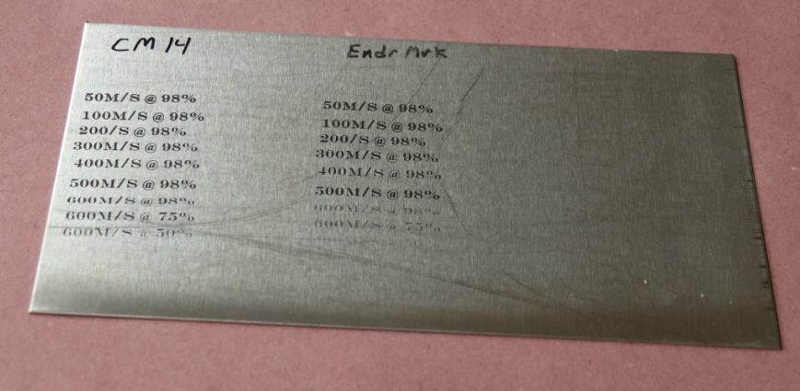

Aluminum

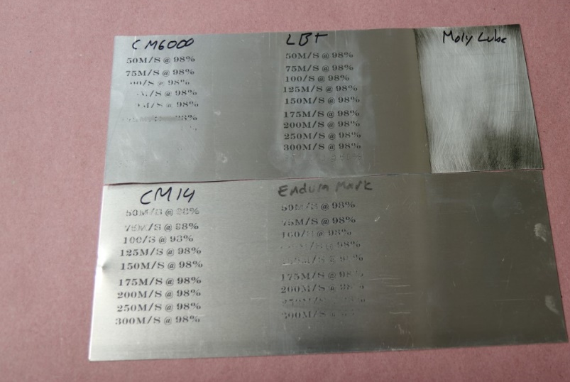

Copper
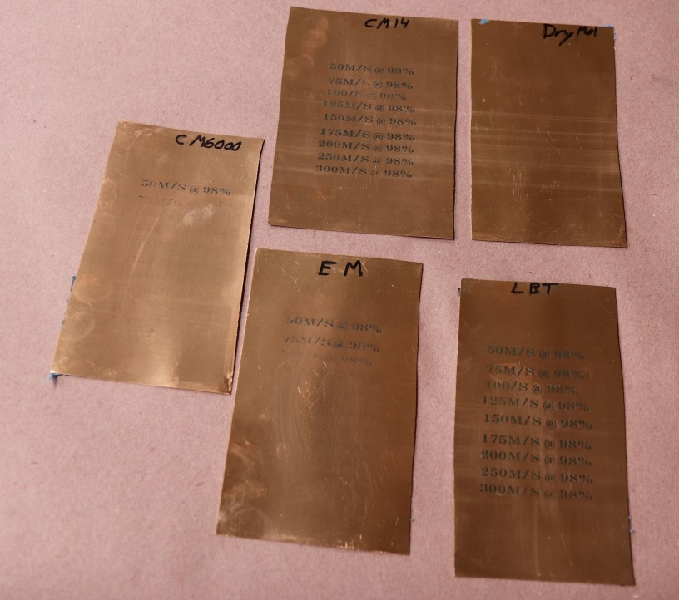

Brass

Other factors
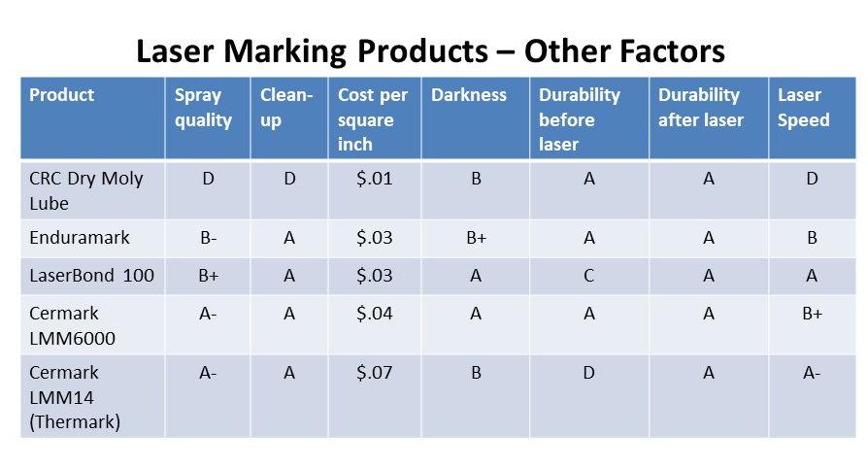
Spray quality: Most of the products laid down a respectable coating, with high quality aerosol tips that were similar to a spray paint can. Enduramark is not available in an aerosol can, and I could not achieve the same quality of coating with the spray system that was provided, although it seemed adequate. CRC Moly Lube, which is not intended for laser marking, produced an inconsistent film with lots of splatters.

Cleanup: CRC Moly Lube required some work to remove, and the rest were pretty easy, requiring only water and light scrubbing with a soft towel. LaserBond 100 and Cermark LMM14 were particularly easy to clean up.
Cost per square inch. There was a sizeable range of 7X in the cost of using each of the products from the cheapest to most expensive, which I estimated based on the coverage of each product. CRC Moly Lube provided the cheapest option, but with its marginal results, most economically minded laser operators will look to the $.03/sq. in. range where LaserBond 100 and Enduramark land.
Darkness: This is not only a subjective category, but people vary in terms of how dark they prefer a mark to be. My preference is the darker the better, so I graded them strictly on how dark of a mark each product left. While all products left a mark that would generally be consider acceptable, LaserBond 100 and Cermark LMM6000 led the pack in this category.
Durability before laser. Some production shops prefer to apply the laser marking spray onto metal blanks and keep them in inventory until an order is received. Not all of the products are suitable for this type of workflow; the standouts include Cermark LMM6000, Enduramark, and CRC Moly Lube. The other products should be taken directly to laser after the spray has dried, or risk having the film scratched with inadvertent contact.
Durability after laser. When processed using the optimal laser settings for each product on each metal, all of the products were able to produce a mark that was very durable and resistant to both chemical and abrasive attempts to remove the image. The marks can be removed with aggressive scrubbing but should hold up for many years through normal use and nominal wear and tear.
Laser speed. The ability to mark a product at higher speeds is an important factor in a production shop because the faster the laser can be run, the more work can be processed in a given period of time. LaserBond 100 led the speed category on all of the metals tested, while LMM6000 was a contender in this category on stainless steel and brass.

Conclusions
The choice of the right product depends on your business model and operating environment, but here are a few closing thoughts:
- CRC Dry Moly Lube is a cheap product that can produce decent results on high quality stainless steel with extremely slow laser settings relative to the purpose-built products in these tests. I recommend it for hobbyists who have a small run of projects and want to dabble with laser marking on steel. It is not reliable or fast enough for use in a production shop, however, where both quality production efficiency are crucial.
- If you run a high-volume shop and prefer to set up multiple blanks in a batch process mode, and inventory them until you receive an order, then Cermark LMM6000 or Enduramark would be worth considering, as they both held up well before running the laser job.
- If you are looking for a versatile product that works well on a variety of metals at an economical price point, my overall top recommendation would be LaserBond 100.

Sources
LaserBond 100: http://laserbondingtech.com/
Cermark: https://www.johnsonplastics.com/engraving/engraving-supplies/cermark/
Enduramark: https://enduramark.com/
CRC Dry Moly Lube: http://www.crcindustries.com/products/dry-moly-lube-11-wt-oz-03084.html

Paul Mayer is a laser engraver enthusiast, woodworker and technologist. His work can be found on his YouTube channel at https://www.youtube.com/c/ToolMetrix.

